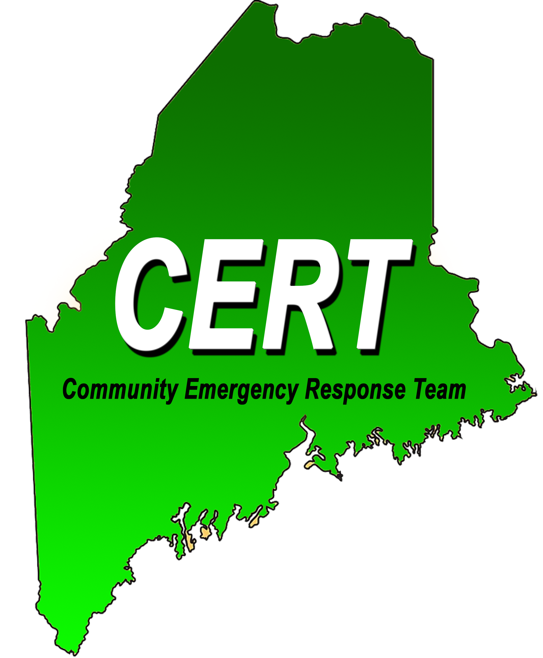

**The**

**(Local, County, or State Agency) has agreed to sponsor**

**the** **Community Emergency Response Team (CERT).**

**Agency Name:**

**Address:**

**Official Agency Representative:**

**Phone:** **Email:**

**Signature:****Date:**

**Type of CERT: (Check One)**

**Community** **Teen** **Campus** **Tribal**

**Primary Programs (Check All That Apply)**

**CERT**

**ARES**

**RACES**

**CART**

**Please submit completed Form to State CERT Coordinator, Kelsey Preecs, kelsey.preecs@maine.gov**

**Submitted to State CERT Coordinator by:**

**Date Submitted:**

**Date Received by State CERT Coordinator:**

**Approved:****Denied:**